Challenge Kneat

This is a console application that has the function of displaying spacecraft information and calculating the number of stops needed to make a distance for each ship.

The app consume an API at: <https://swapi.co/>

**Requirements**

* Net core 2.2

**Open the app**

* After downloading the solution from GitHub, find and open the folder \KneatChallenge\bin\Release\netcoreapp2.2\publish



* Open the KneatChallenge.ConsoleApp.exe file

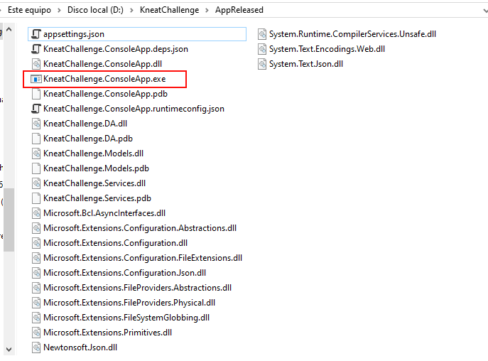

**Configuration**

* The API URI can be updated in the file:





**Manual**

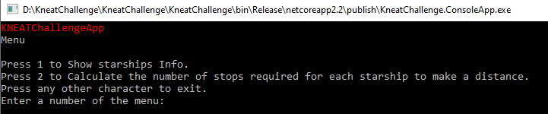

The app has 2 functions:

1. Show information for each Starships, the information is composed of:  
   - Name  
   - MGLT: The Maximum number of Megalights this starship can travel in a standard hour.  
   - consumables: The maximum length of time that this starship can provide consumables for its entire crew without having to resupply.

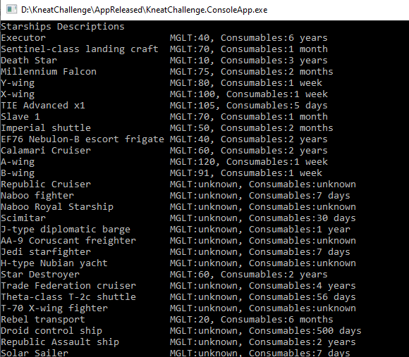

1. Calculate the number of stops required for each starship to make a distance.  
     
   First of all must enter the distance

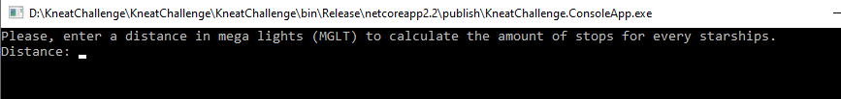

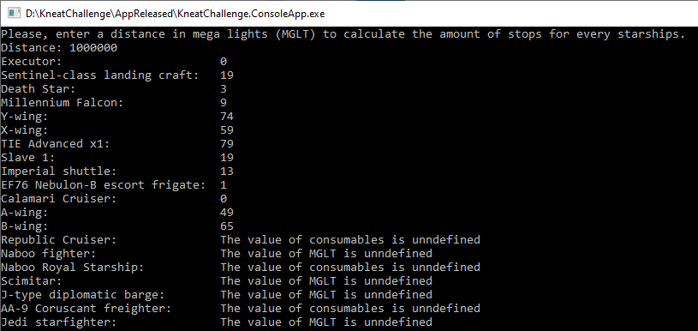

After an action the app will return to the menu, to get out press any other character.